*HAWK +*

Team Profile

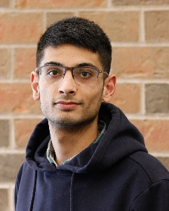

Asrar Farooq

* **Email**: [asrarfarooq@ku.edu](mailto:asrarfarooq@ku.edu)
* **Phone Number**: (785) 979-6966
* **Specialties**: Front-End Development, UI & UX Designer
* **Languages**: HTML, CSS, JavaScript, Python, C++
* **Availability**:
  + **In-Person**: Monday 1-3 pm
  + **Microsoft Teams**: Wednesday 1-4 pm, Friday 12-1 & 2-3 pm
  + **Email/Text:** Anytime

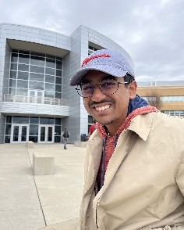

Srikar Turaga

* **Email**: [srikar.turaga@ku.edu](mailto:srikar.turaga@ku.edu)
* **Phone Number**: (913) 605-4918
* **Specialties**: Full-Stack Developer
* **Languages**: C#, .NET, Angular, TypeScript/JavaScript, HTML, CSS, C++
* **Availability**:
  + **In-Person**: Monday 1-4 pm
  + **Microsoft Teams**: Wednesday/Friday 1-5 pm, Weekends based on importance/availability
  + **Email/Text**: Anytime

Team Profile

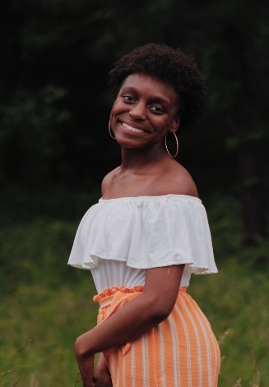

Sakkyra King

* **Email:** [sakkyra23@ku.edu](mailto:sakkyra23@ku.edu)
* **Phone Number**: (573) 257-7426
* **Specialties**: IT, Problem Solving, Well versed in entrepreneurship & marketing
* **Languages**: Python
* **Availability** (Due to Change):
  + **In-Person**: Monday 12-2:45 pm (hour before lab/lab time), Tuesday/Wednesday/Friday 4-7 pm, Saturday 1-6 pm
  + **Microsoft Teams**: Same as In-Person hours
  + **Email/Text**: Anytime

Sarah Martinez

* **Email:** [Martinezs99@ku.edu](mailto:Martinezs99@ku.edu)
* **Phone Number**: (620) 510-9439
* **Specialties**: IT, Digital Art, Customer Service
* **Languages**: Python, Matlab
* **Availability**:
  + **In-Person**: Monday 12-2:50 pm, Tuesday/Thursday 12:30-2:15 pm, Wednesday 2-3 pm, Free after 5 pm everyday
  + **Microsoft Teams**: Same as In-Person Hours
  + **Email/Text**: Anytime

Team Roles

Sakkyra (Project Leader)

* Responsibilities:
  + Compiling "original project deliverables" which has been accomplished by all team members.
  + Directing the project, and therefore leading the project portion of meetings
  + Reporting to the professor project technical issues not resolvable within the team

Asrar (Data Administrator, Assistant Project Leader)

* Responsibilities:
  + Getting ready (in final form) all "project deliverables", with the help of the team, prior to publication
  + Checking for consistency of deliverables
  + Helping the project leader with his/her duties
  + Aiding in the compilation of deliverables

Srikar (Technical Leader)

* Responsibilities:
  + Publishing project deliverables on the web
  + Maintaining Web Page for Team Project

Sarah (Project Administrator)

* Responsibilities:
  + Setting up all meetings of the team
  + Settling team and project disagreements (see procedures further below)
  + Compiling minutes of meetings and progress log entries
  + Posting minutes and log entries to the deliverable’s website (minutes are required each week)
  + Managing meetings

|  |  |  |  |
| --- | --- | --- | --- |
| Date | Minutes | Attendance | Purpose |
| 09/07/2022 | 47 | Sakkyra, Sarah, Asrar, and Srikar | Distributed Roles, discussed potential project ideas, and produced Team Name and Logo |
| 09/09/2022 | 54 | Asrar, Srikar | Setup webpage for team project and added access to repo for team members |
| 09/14/2022 | 52 | Sakkrya, Sarah, Asrar, Srikar | Vision Statement |
| 09/16/2022 | 12 | Sakkrya, Sarah, Asrar, Srikar | Vision Statement Recheck |
|  |  |  |  |
|  |  |  |  |
|  |  |  |  |
|  |  |  |  |
|  |  |  |  |
|  |  |  |  |
|  |  |  |  |
|  |  |  |  |
|  |  |  |  |
|  |  |  |  |
|  |  |  |  |
|  |  |  |  |
|  |  |  |  |
|  |  |  |  |
|  |  |  |  |
|  |  |  |  |
|  |  |  |  |
|  |  |  |  |

**Team Meeting Log**